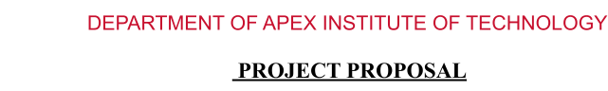

# PH20AIML4A

1. **Project Title:-**

**COVID-19 Detection Model**

# Project Scope:-

Early detection of COVID-19 infection is helpful for treatment and quarantine. The aim of the project is to detect COVID 19 from chest X-rays. This can help save the patients at an early stage.

# Requirements:-

* + **Python**
  + **Tensorflow**
  + **Keras (Deep learning library)**
  + **Matplotlib (Visualization)**
  + **Seaborn (Visualization)**
  + **CNN**

**STUDENTS DETAILS**

|  |  |  |  |
| --- | --- | --- | --- |
| **Name** | **UID** | **Mobile Number** | **Signature** |
| MANASIJ HALDAR | 20BCS6838 | 7003341179 |  |

**APPROVAL AND AUTHORITY TO PROCEED**

We approve the project as described above, and authorize the team to proceed.

|  |  |  |
| --- | --- | --- |
| **Name** | **Title** | **Signature (with Date)** |
| Prabhjot Singh Manocha | Supervisor |  |